**Complaint Redressal System**

**Developer**

**Mounika Valiveti**

A passionate developer from India

**Overview**

ABC Telecom Ltd. is one of India’s major telecommunication service providers offering landline, mobile phone and Fiber optic broadband services across the country. Their customer services group is interested in providing a set of customer redressal services through the development of a new application using the state-of-art technologies such as Spring-boot for the development of java-based services, and UI using Angular and integrate them suitably, so that all the necessary services are taken care of through this application. They want to have an online complaint management system where the customers can raise complaints regarding their landlines and broadband services..

**Tools Used**

1. Eclipse: An IDE to code for the application

2. Java: A programming language to develop the prototype

3. Angular: To create view layer

4. Maven: A build tool for adding all the external dependencies

5. Git: To connect and push files from the local system to GitHub

6. GitHub: To store the application code and track its versions

7. VS Code: To code for frontend

8. Docker: To deploy jar in a container to access it from EC2

**Frameworks & Techniques Used**

1. Spring Boot: Popular Java Framework to achieve inversion of control and dependency injection

2. Spring MVC: Model View Controller by Spring.

3. Angular: A popular JavaScript framework to design view layer

**Application Flow Chart**

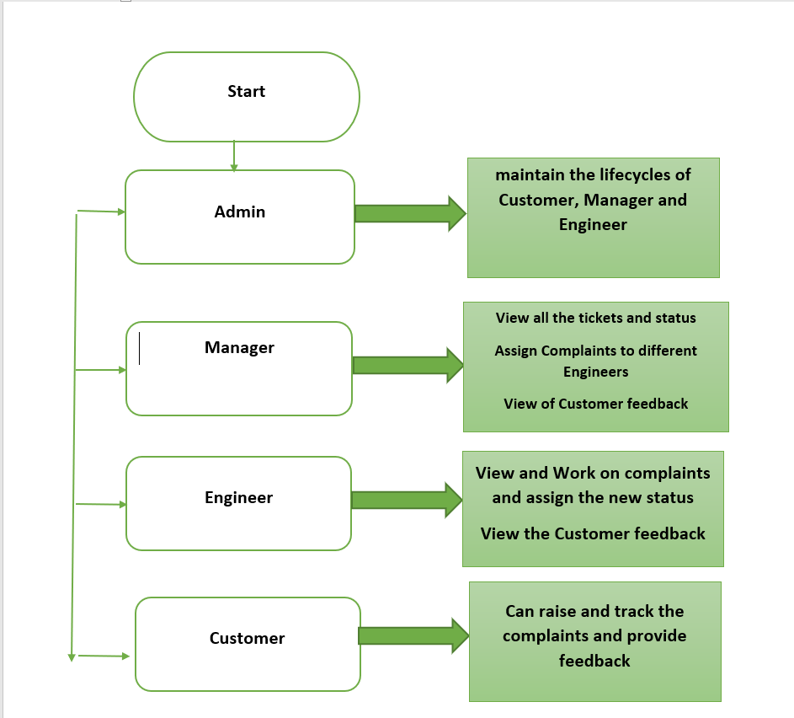

**Admin Login Page:**

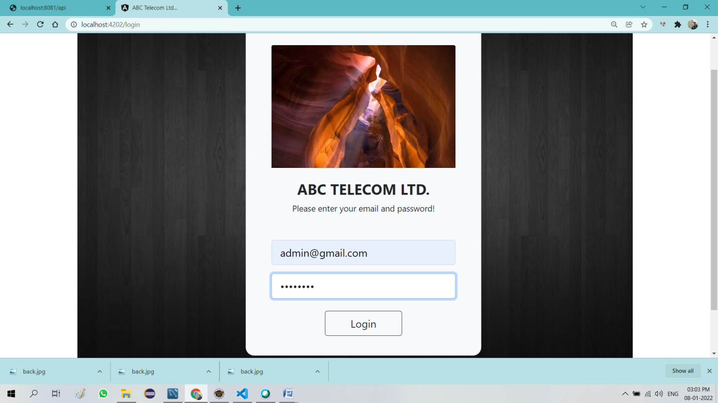

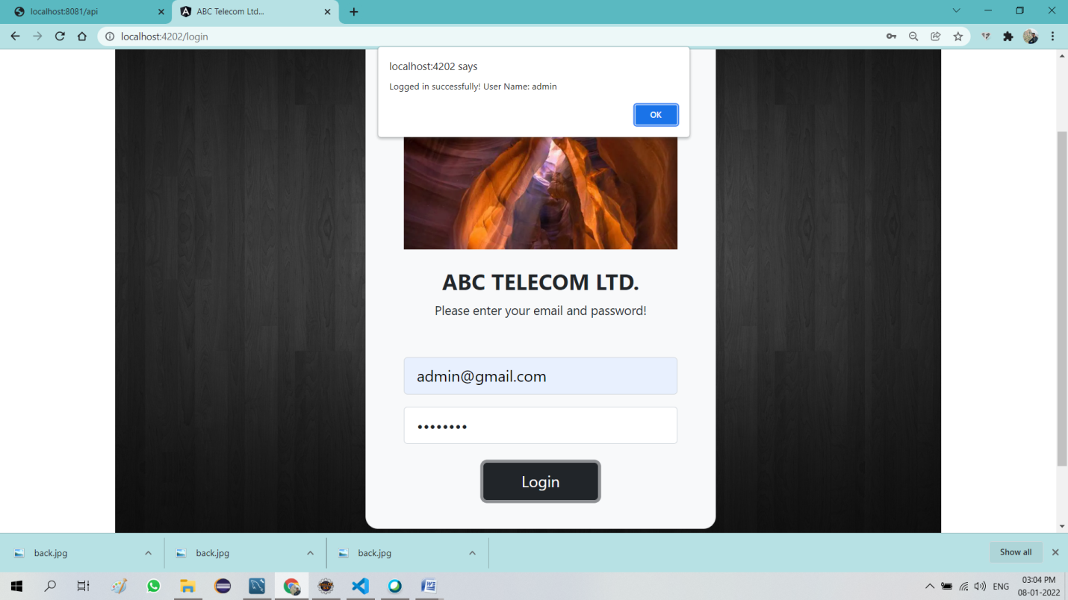

**Admin Home Page**

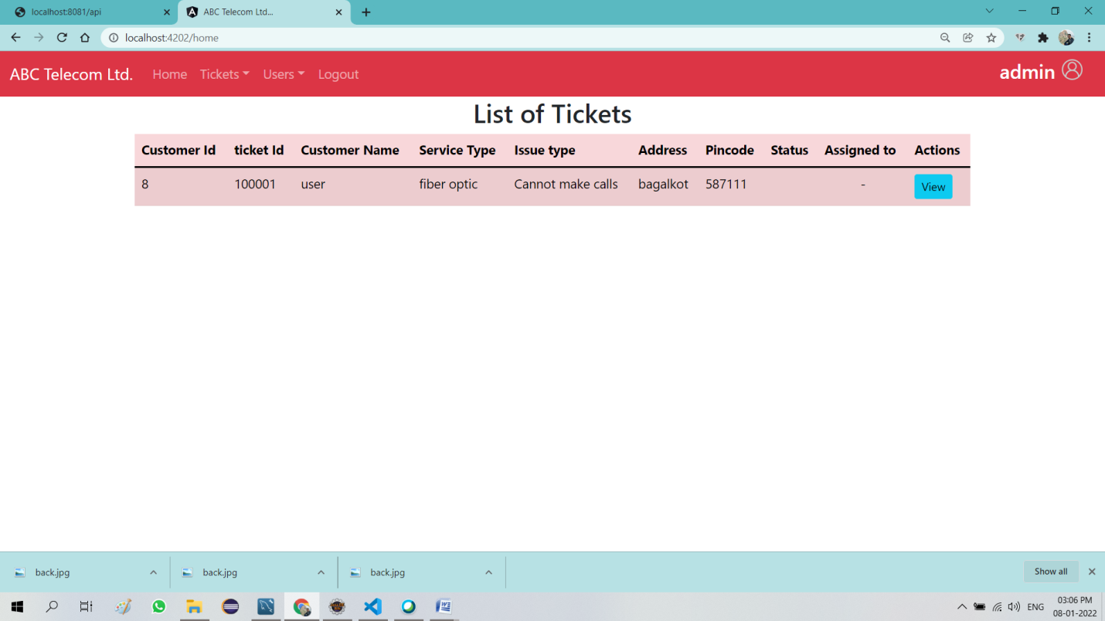

**Admin can create and manages the lifecycle of different users**

* Customer
* Manager
* Engineer

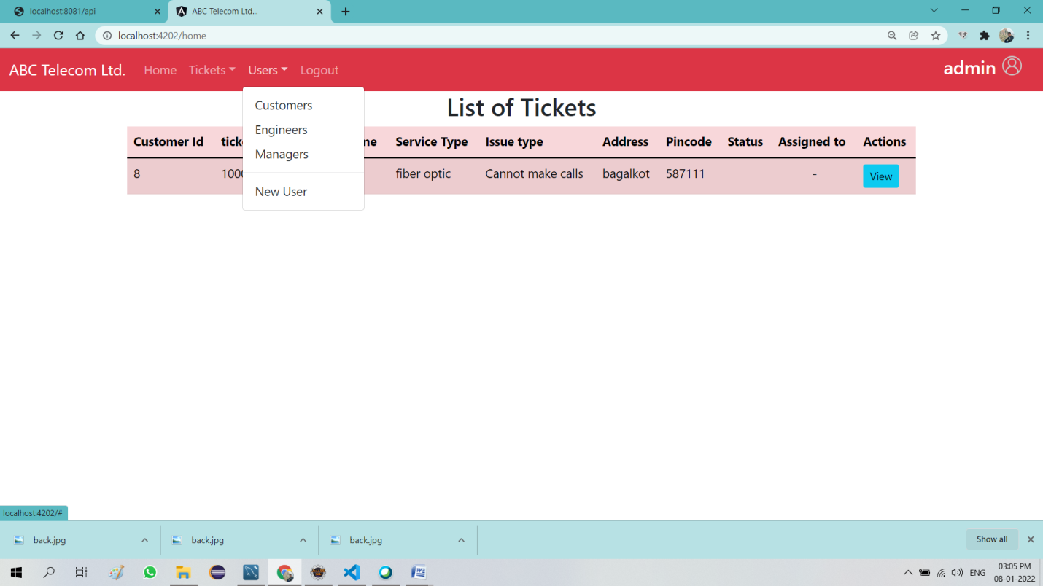

**Admin can create new users**

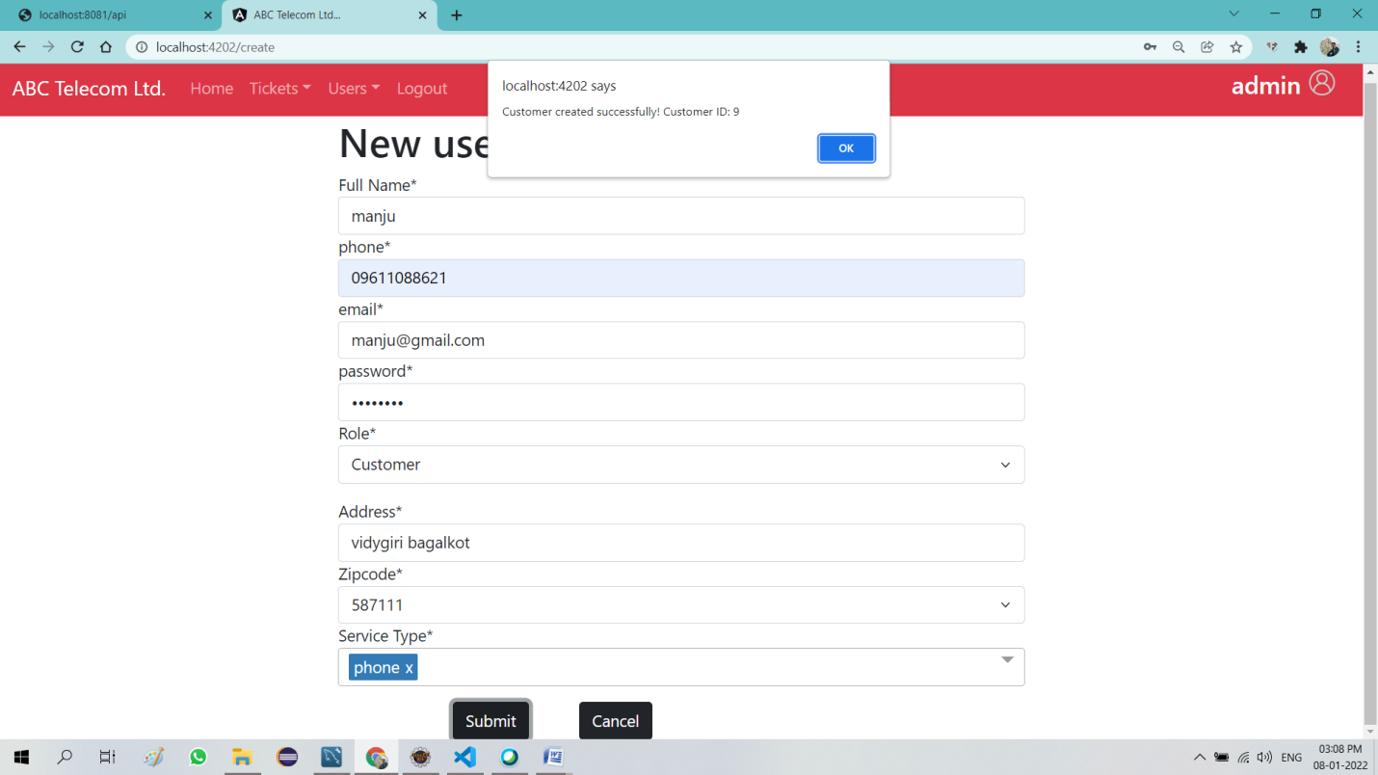

**Admin can see list of Customer**

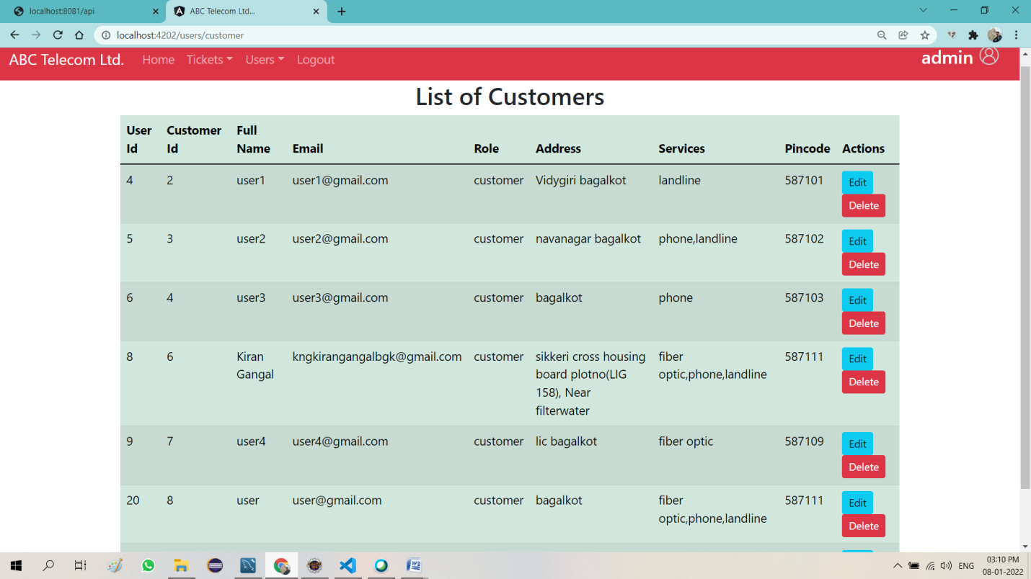

**Admin can see list of Engineers**

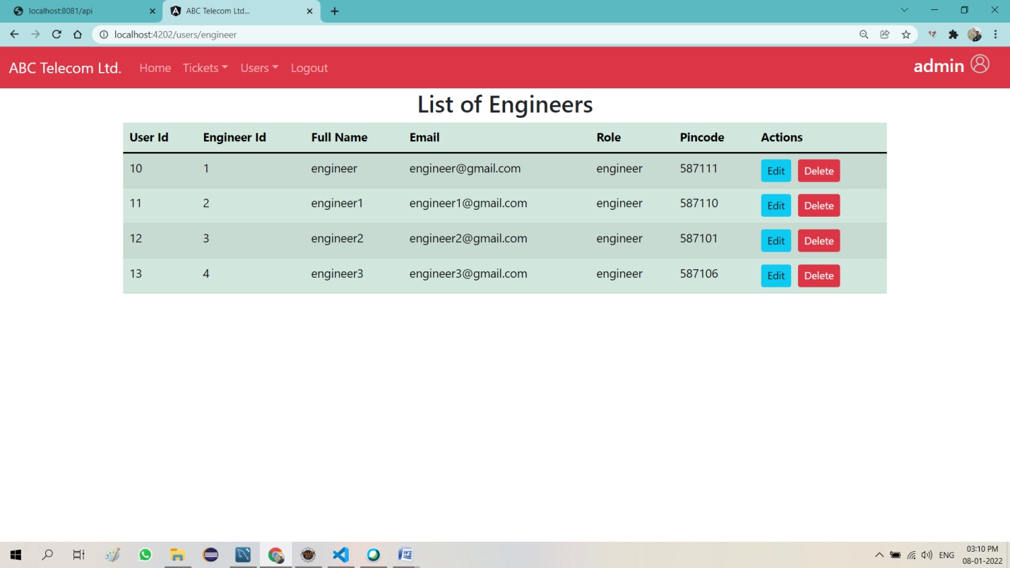

**Admin can see list of Managers**

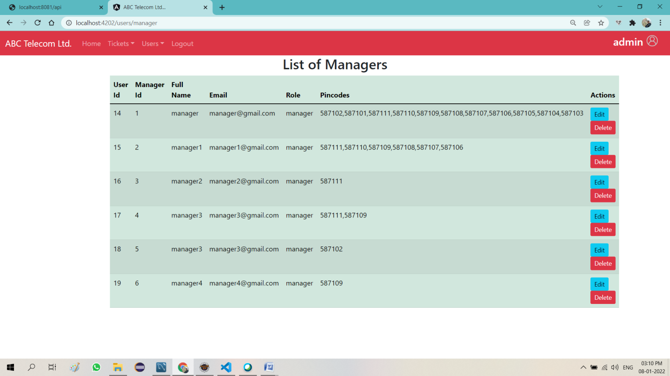

**Admin can see List of Tickets**

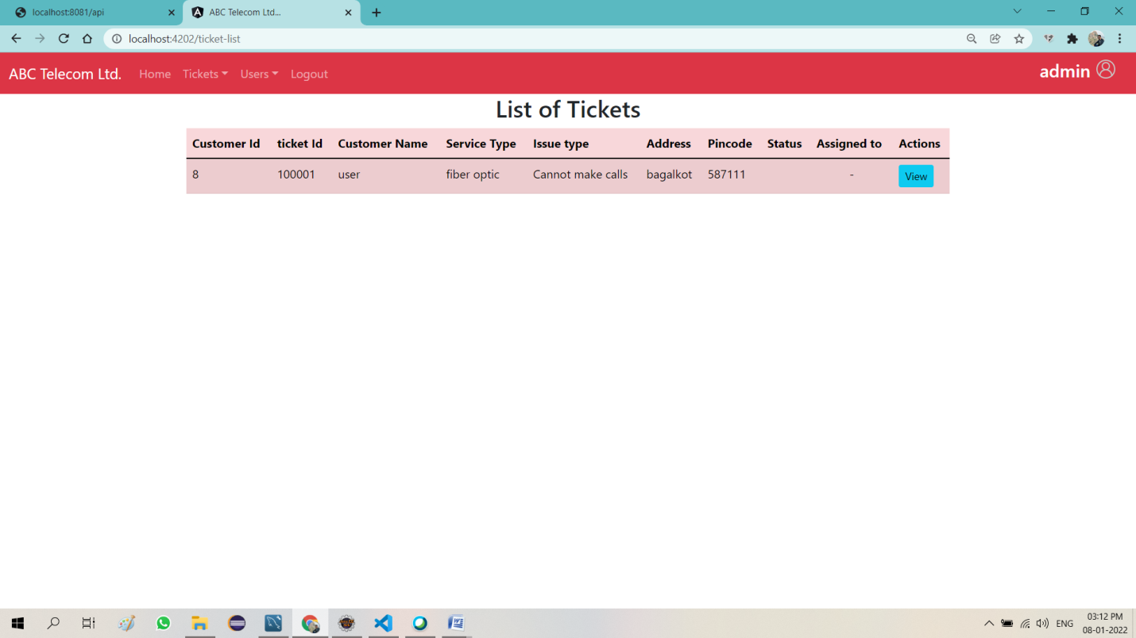

**Admin can Edit customer /Engineer/Manger list**

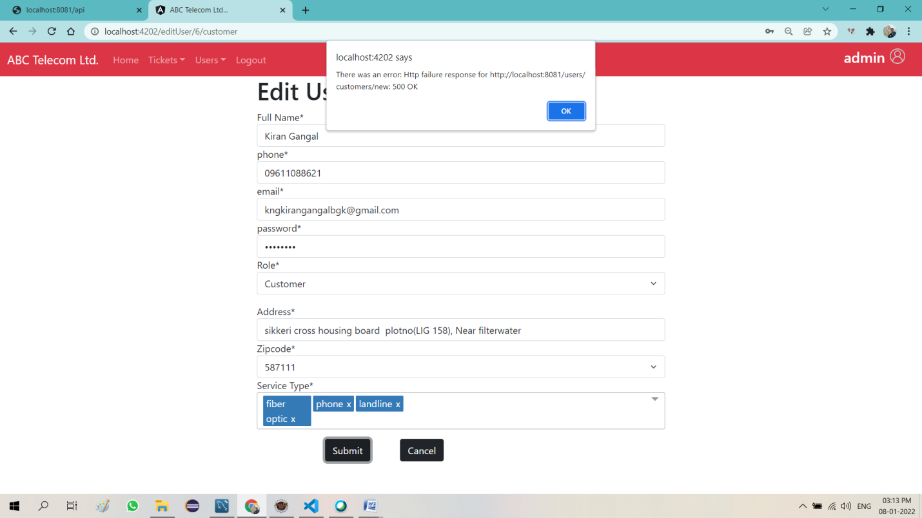

**Admin can Edit or Feedback for Ticket**

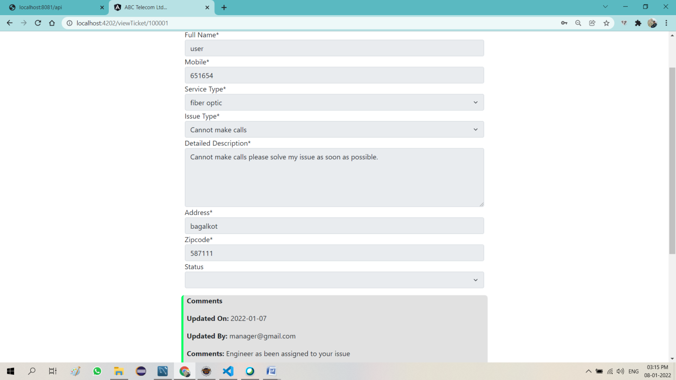

**Admin can Edit or Feedback for Ticket**

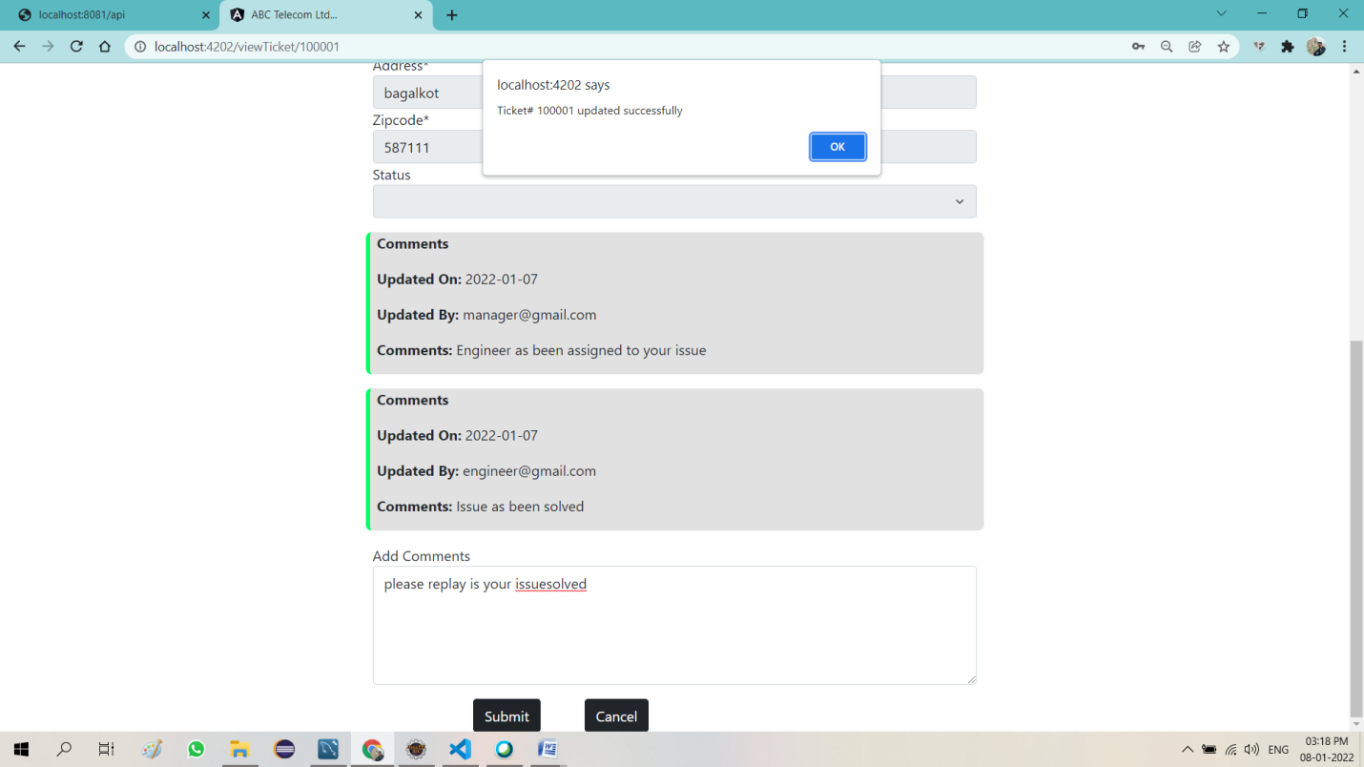

**Manger login successful**

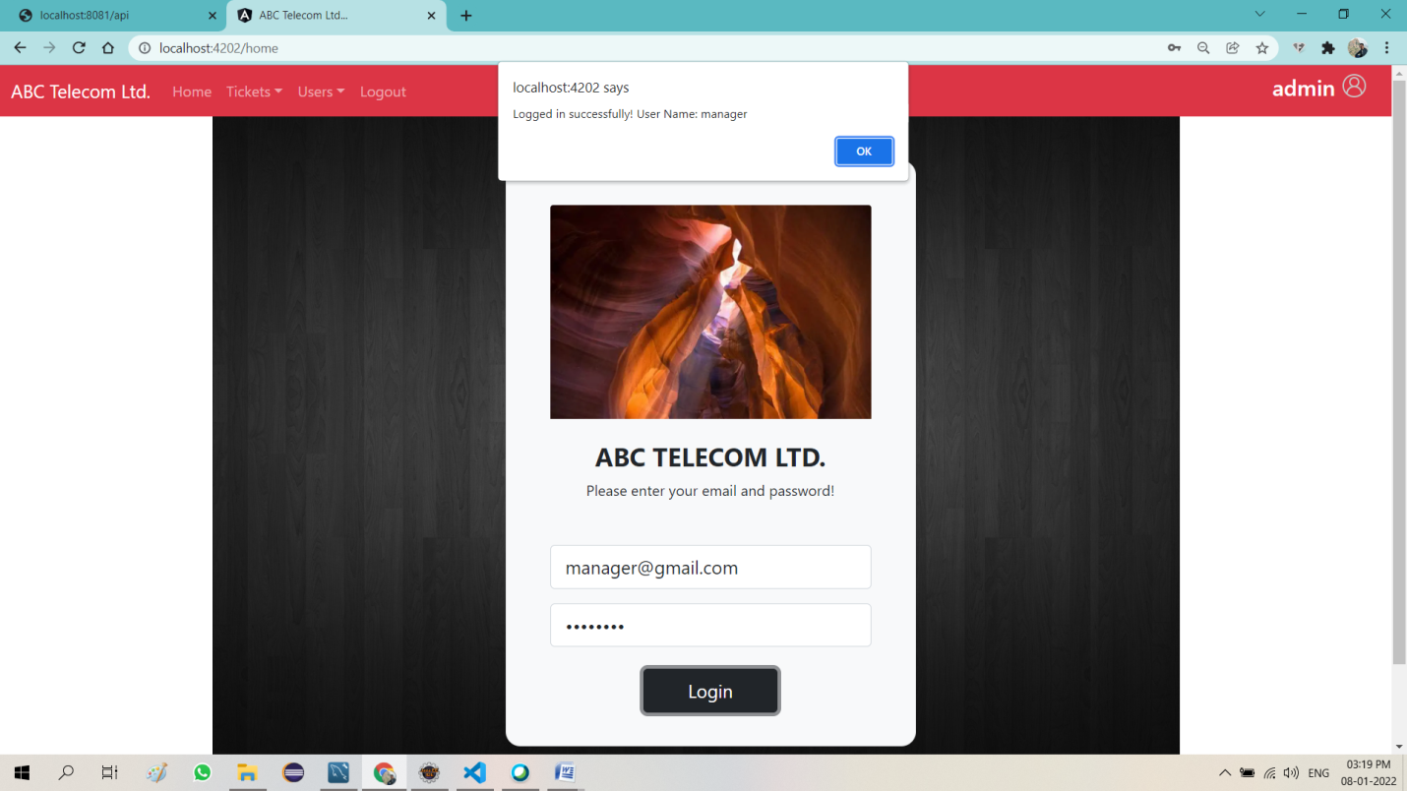

**Manger Home page**

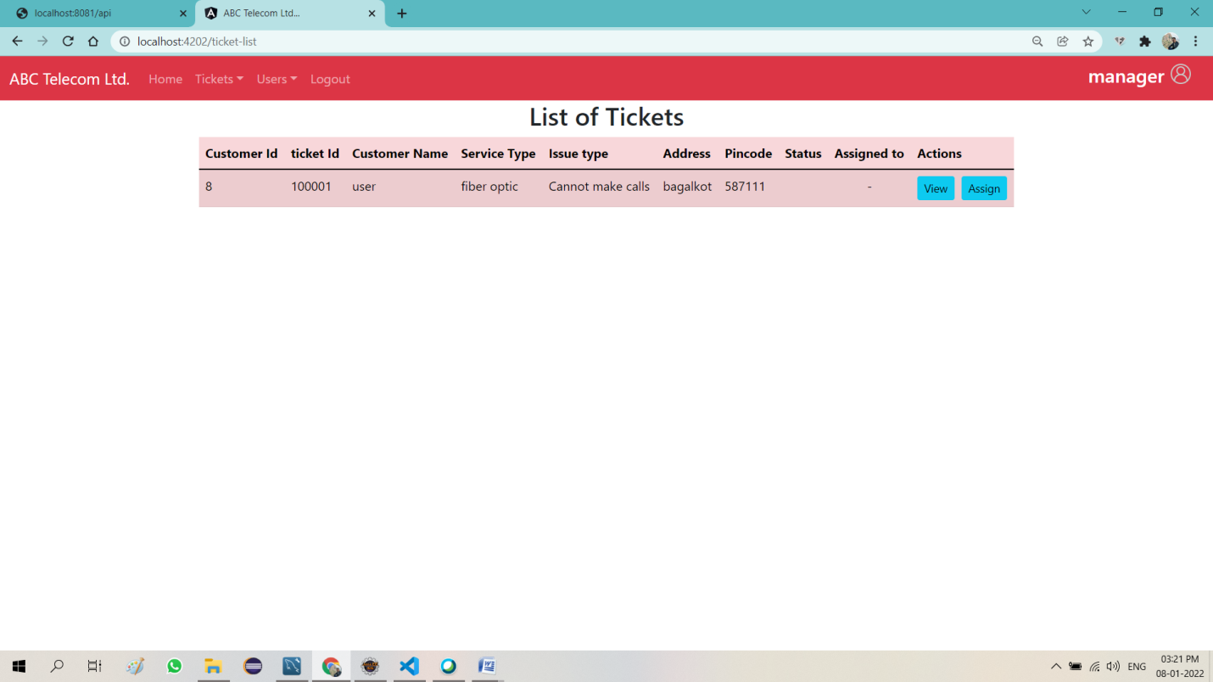

**Manger can view Ticket**

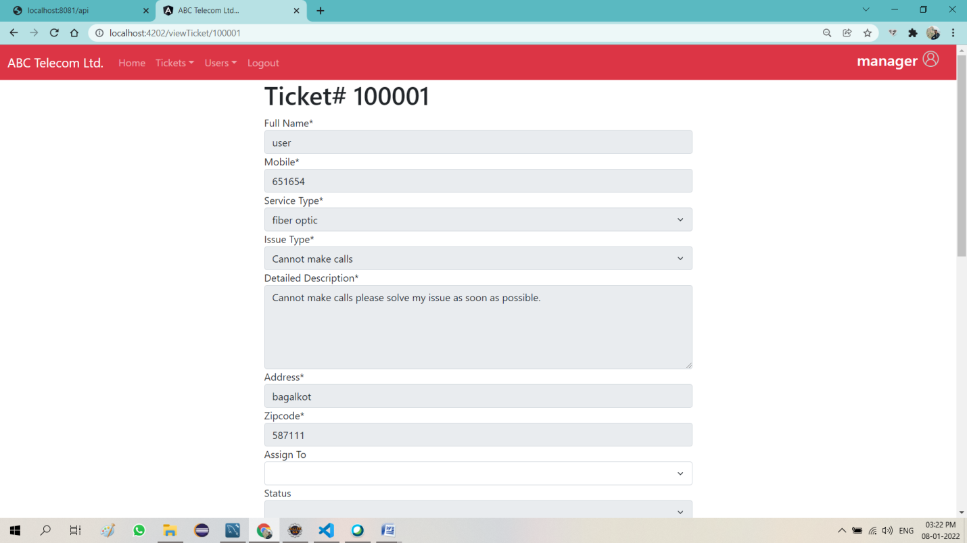

**Manger can Assign ticket to Engineer**

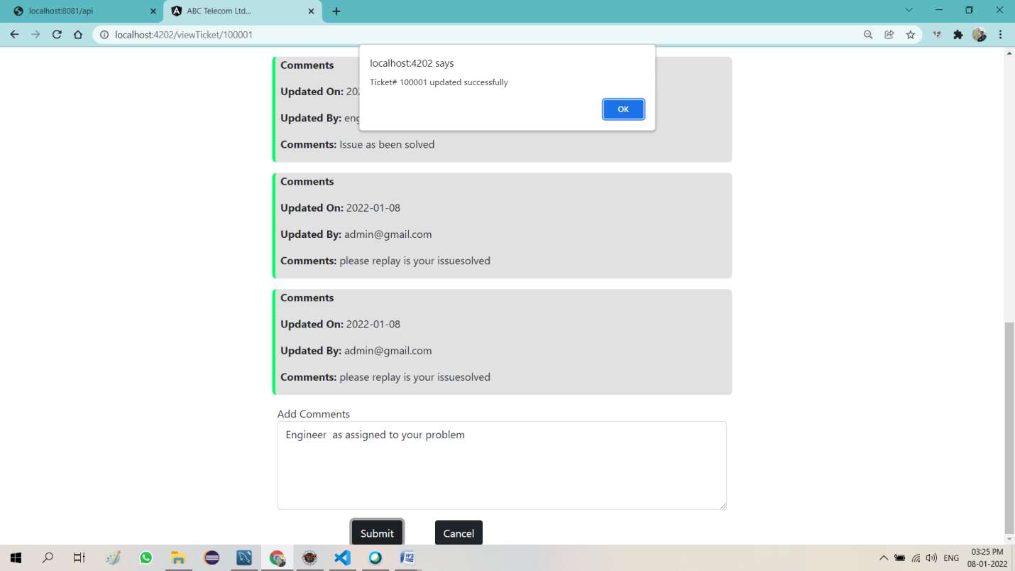

**Engineer Login success and home page**

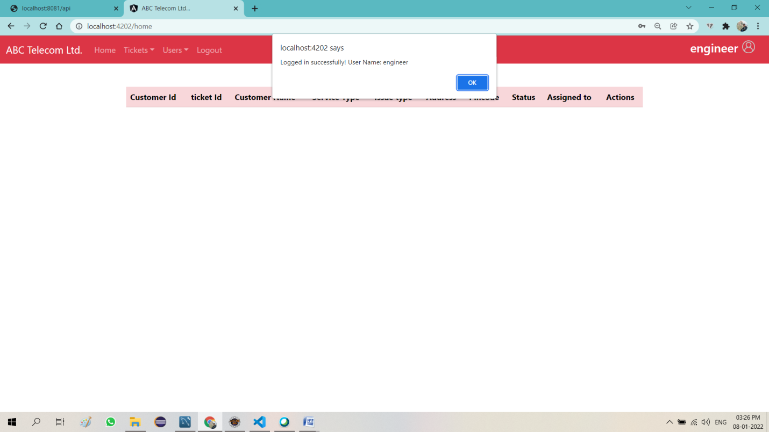

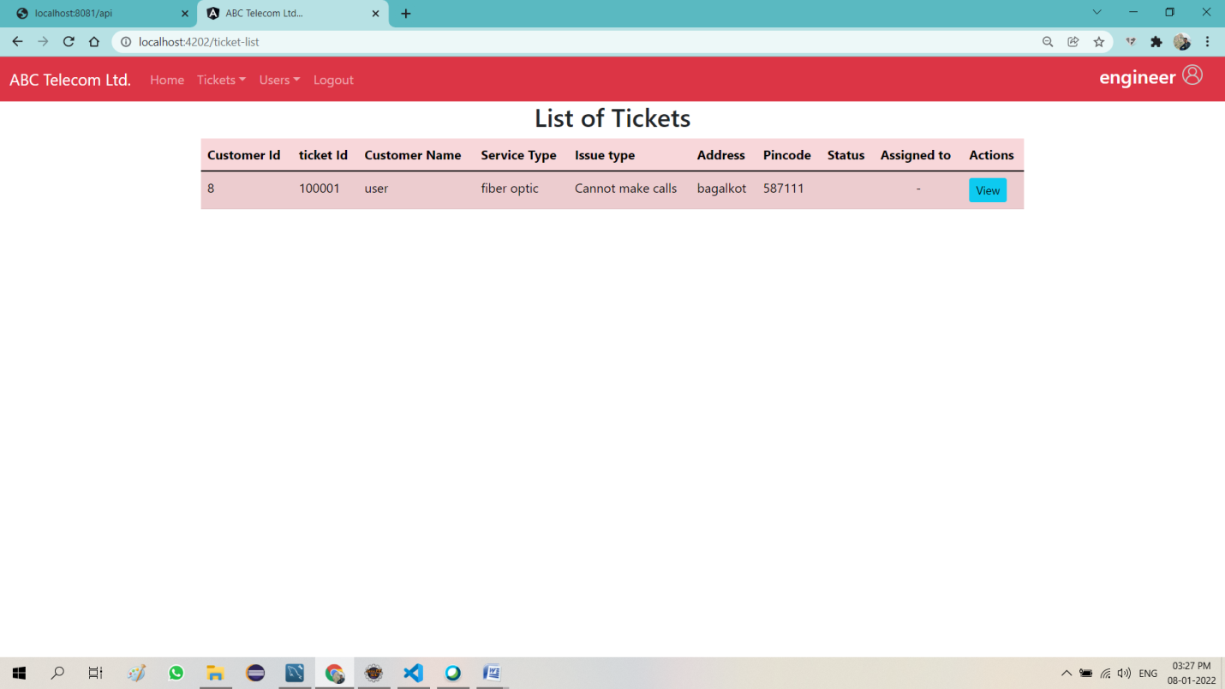

**Engineer can view the ticket and solve the problem**

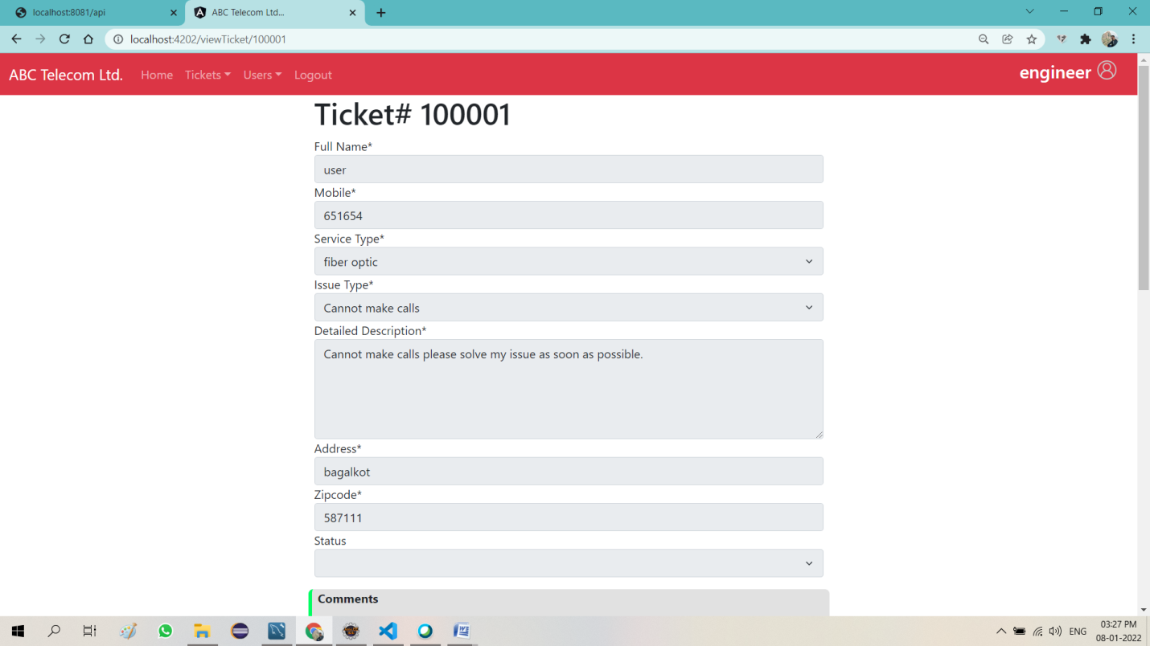

**Engineer can give feedback to customer**

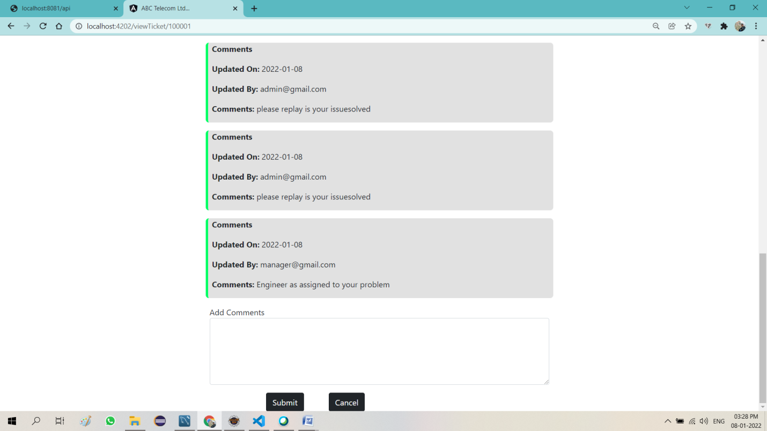

**Customer login Success**

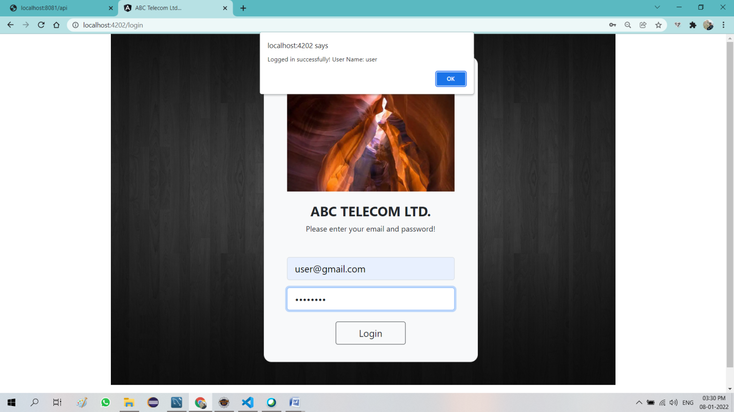

**Customer home page**

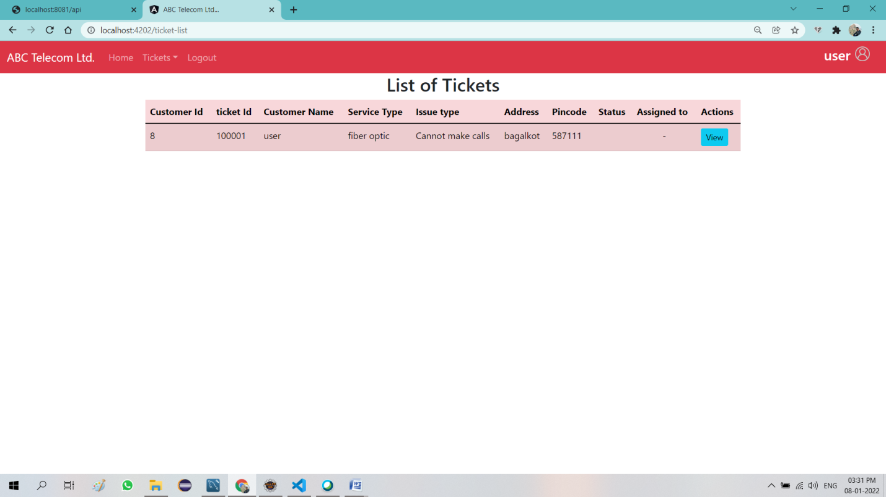

**Customer can create new Ticket**

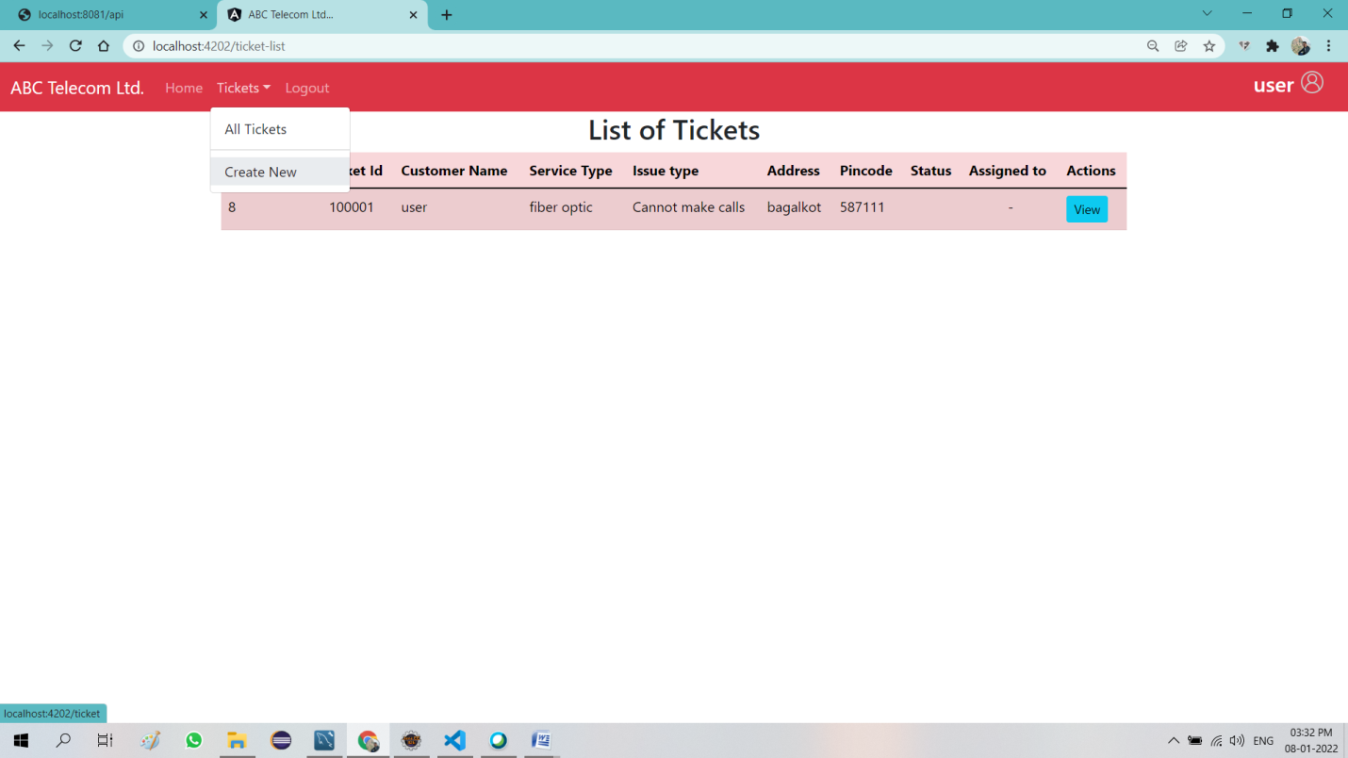

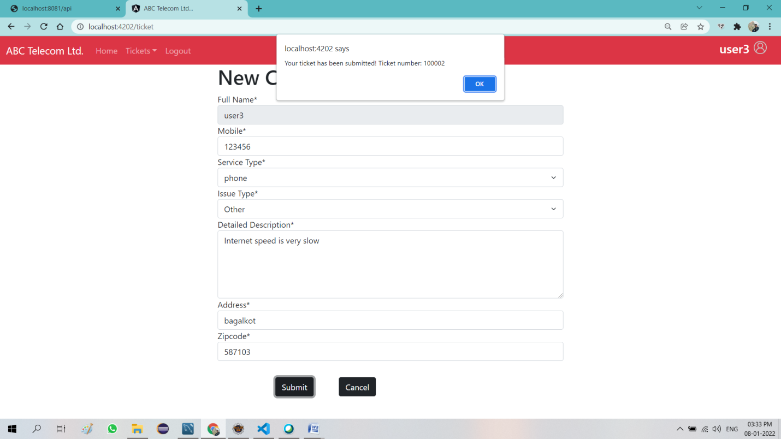

**Mysql Database**

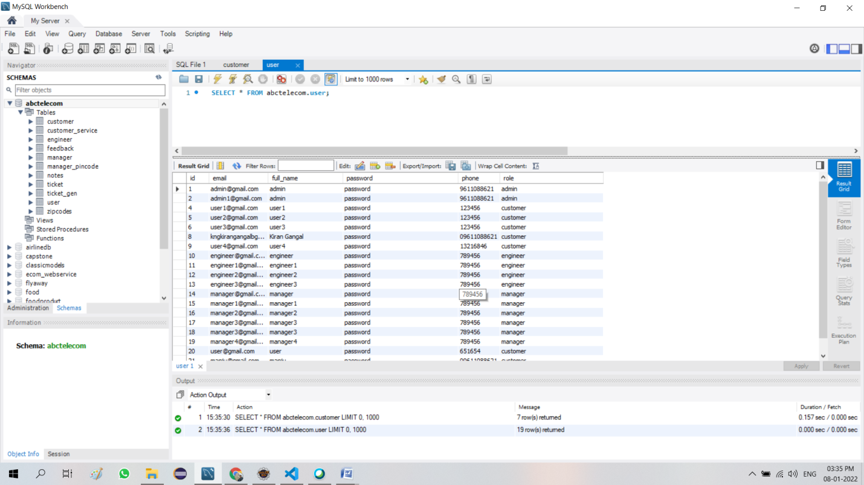

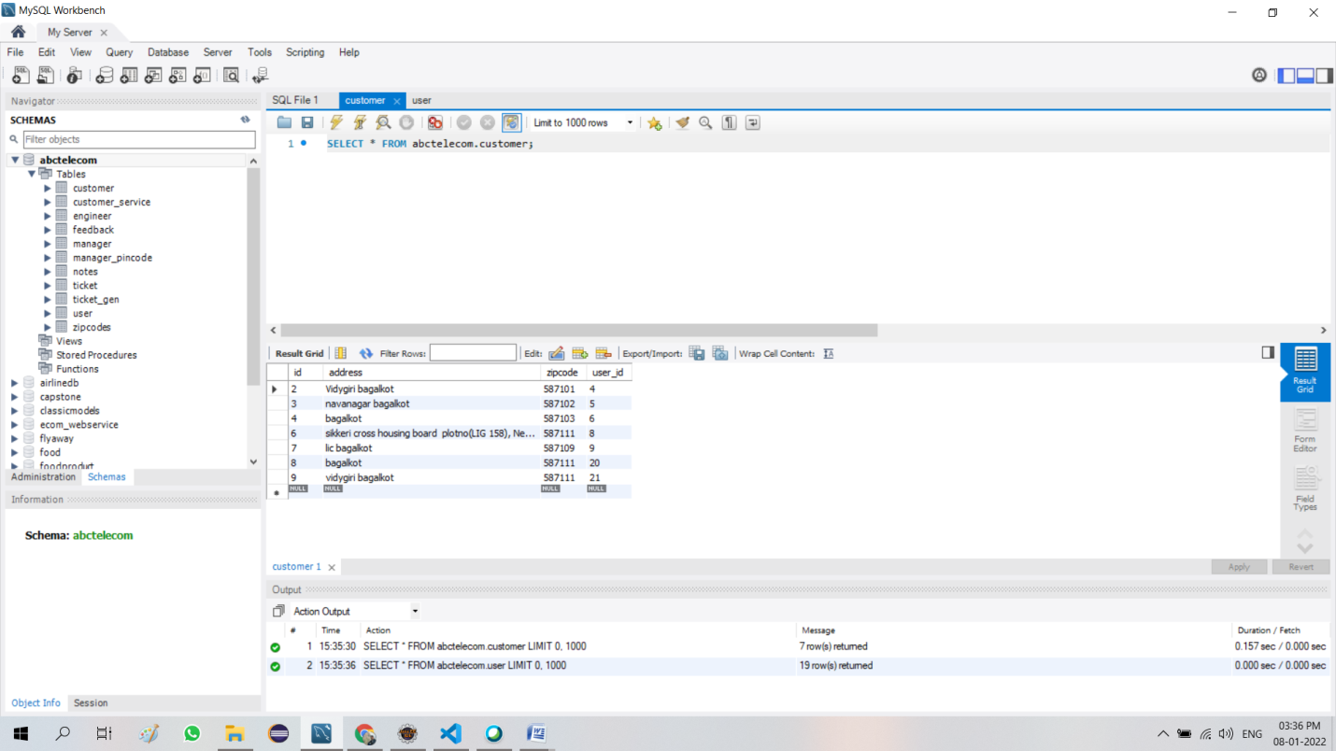

**Eclipse code running(Back End)**

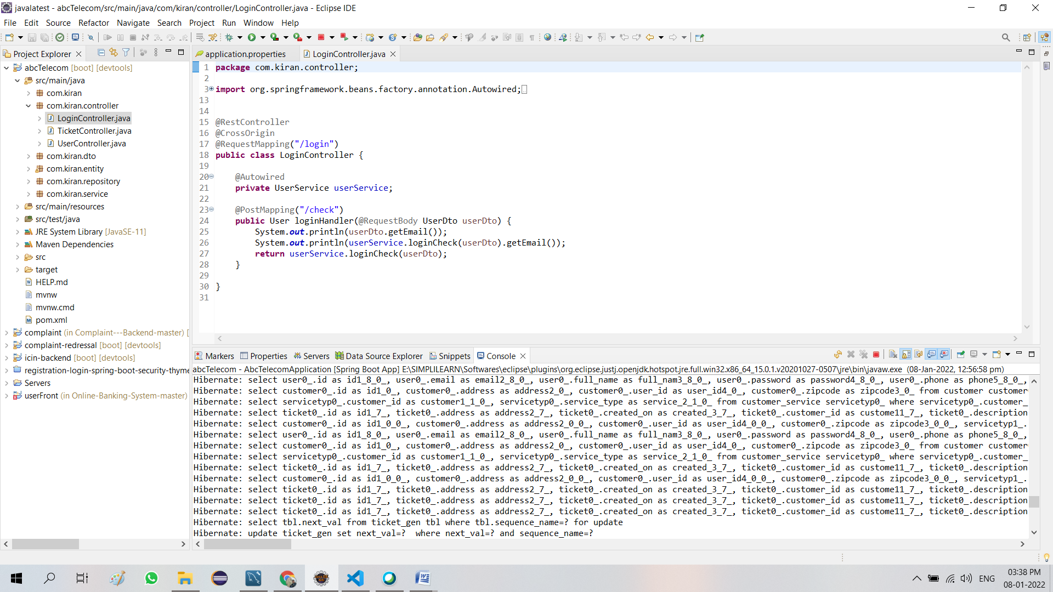

**Visual Studio (Front End)**

